**Software Requirements Specification**

**For**

**ONLINE PLACEMENT AGENCY**

**Submitted By -**

**Group No. 09**

**ANKUR YADAV (220950120030)**

**ARVIND CHANDRAKAR (220950120038)**

**ASHISH VERMA (220950120042)**

**DOLLY TEOTIA (220950120069)**

**RICHA SHARMA (220950120147)**

**CDAC, Bengaluru**

**INDEX**

**Table of Contents**

1. **Introduction**

1.1 Purpose

1.2 Product Scope

1.3 References

1. **Overall Description**

2.1 Objective

* 1. **External Interfaces**

3.1 User Interfaces GUI and Help Issues

3.2 Security Issues

1. **Requirements**

4.1 Initial non-functional requirements

4.2 Functional requirement specifications

1. **List of Functions**

5.1 Functional Description

1. **Designing Documentation**

6.1 Use case Diagram

6.2 Entity Relationship

**1. Introduction**

As we know that searching of jobs is so difficult in proficient areas, so this portal is developed to providing the simple and good job searching. With the help of this portal easily the job seeker can submit their resume and get the lot of opportunity of the job related to their profile. And by this website the companies or employer can also find the good and well profiled resume.

**1.1 Purpose**

The Online Placement Agency is a job portal system that is to be developed, provides the members with jobs information, online applying for jobs and many other facilities. This system provides service to the job applicants to search for working opportunities.

This Portal will allow job provider to establish one to one relationship with candidates. It will primarily focus on the posting and management of job vacancies. This system is designed such that ultimately all vacancies will be posted online and would offer employers the facilities to post their vacancies online. It helps to review and manage the resulting applications efficiently through the web. Employer can also find the resume according to key skill in very less amount of time.

**1.2 Product Scope**

As of Indian market, there is ample opportunities for the job portal sites, as more and more number of educated and skilled young people are coming out each and every year. Also, as the growth rate of India is zooming to be at a healthy rate over 7%, so it is boom time for corporate also. So, a greater number of lucrative careers will be available for the job seekers. So, it is now the right period for the job portal sites to think out of the box, and to make most of the opportunities available.

**1.3 References**

* IEEE. IEEE Std 830-1998 IEEE Recommended Practice for Software Requirements Specifications. IEEE Computer Society, 1998.

**2. Overall Description**

**2.1 Objective**

The “Online Placement Agency” has been developed to override the problems prevailing in searching for perfect job in respective field. This specification will cover the user (Job Seeker) and Job Provider registration related portions. The detailed information about how User and Job Provider will register to the application and various approvals will be provided. The specification describes how the User choose specific job and apply for the job and how Job Provider can see the number of candidate has been applied for the job what they have provided.

It will lead to error-free, secure, reliable and best job providing and job searching system. It will help user to find job in their respective field.

The user can easily Register himself/herself by providing few details and can login with the username and password. After logging to the website, he/she can look on to the listed available jobs and also the jobs for which they have applied.

**3. External Interfaces**

**3.1 User Interfaces GUI and Help Issues:**

These screens will be user friendly and help will be available at all levels. Help can be any type like site map and also online help, help for entering the standard codes i.e., List of Values will be provided wherever possible in order to reduce data entry errors. User has to select the proper value from list wherever provided.

E.g.: Picking the date from the given list.

**3.2 Security Issues:**

User at different levels in the hierarchy will have restricted access to information. Only authorized users will be able to access the confidential information. Only the System Administrator will do system administration and maintenance work. And update the information. Various security mechanisms will be provided such as password.

E.g. –

Password protection for valid user.

(Provided by RDBMS) -Password at application level.

**4. Requirements**

**4.1 Initial non-functional requirements**

* Secure access of confidential data (user’s details). SSL (Secure Sockets Layer) can be used.
* 24 X 7 availability.
* Better component design to get better performance at peak time
* Advertisement space relating to new job vacancy where it will effectively catch the user’s attention.
* In addition to the above-mentioned points, due to the highly evolving nature of the project, the following are planned to be delivered if deemed necessary.
* **Efficiency Requirement** - When an “Online Job Portal” is implemented job seekers and employers can view and upload job vacancies respectively from their homes easily without any difficulty.
* **Usability Requirement** - The “Online Job Portal” is designed for a user-friendly environment and ease of use.
* **Reliability Requirement** - The system should provide a reliable environment for both employers and job seekers. All jobs should be reaching the admin without any errors and should be shown to the viewers.
* **Implementation Requirement** - Implementation of the system using ***ReactJS*** in the front end with ***JAVA Spring Boot*** as the back end and it will be used for database connectivity. And the database part is developed by ***MySQL***. Responsive web designing is used for making the portal compatible for any type of screen.
* **Delivery Requirement** - The whole system is expected to be delivered in two months of time with weekly evaluation by the project guide.
* **Database Security** - An unauthorized person cannot access the panel and database, and do not read and write the information.
* **Availability** - This “Online Job Portal” will be available online 24/7 a week.

**4.2 Functional requirements specifications**

It is the primary requirement that is fulfilled by our job portal. It’s allowing the users, and employers to use our portal at the level ease. The purpose of our portal is to provide the full information that is required of the user. Here is the following requirement that is fulfilled by our system.

**USER**

* **User Login**

This feature is used by the user/admin to login into the system. A user/admin must log in with his username and password to the system after registration. If they are invalid, the user is not allowed to enter the system.

* Username and password will be provided after user registration is confirmed.
* Password should be hidden from others while typing it in the field.
* **Register New User**

A new user will have to register in the system by providing essential details in order to apply in the job. The admin must accept a new user.

* The system must be able to verify and validate the information.
* The system must encrypt the password of the user to provide security.
* **Search Jobs**

The user can search for the desired jobs. He can view different jobs. After confirming the login in the search user can select it and apply by providing the necessary details.

* **Upload Resume**

The job seekers can upload their resumes and provide the necessary details if they are interested in jobs.

**ADMIN**

* **Manage Users and Employers**
* The administrator can add users, delete users, and view users.
* **Manage jobs**
* The administrator can add jobs, delete jobs, hide jobs, and view jobs.
* **Manage details**
* The system must identify the login of the admin.
* Admin account should be secured so that only the owner of the portal can access that account.

**EMPLOYER**

* Employer posts for JOB Vacancies whenever there is vacancies.
* Employer can check whether who is applied for that particular job.
* They also can check User’s profile to get perfect candidate for the job vacancies.

**5. List of Functions**

|  |  |  |
| --- | --- | --- |
| **Sr. No.** | **Function ID** | **Name of Function** |
|  |  |  |
| 1. | F-1 | Employers Posts Jobs. |
|  |  |  |
| 2. | F-2 | User Searches for Jobs. |
|  |  |  |
| 3. | F-3 | User Apply for Jobs. |
| ff |  |  |
| 4. | F-4 | Admin Checks & Maintains Employer and Users. |
|  |  |  |
| 5. | F-5 | Admin Updates Profiles. |
|  |  |  |

**5.1 Functional Description:**

**F-1. Function :** Employers Posts Jobs**.**

**Function ID :** F-1

**Purpose:** Whenever there is job vacancies, Employer will post Jobs, which will be displayed on user dashboard, and can be searched by user easily.

**F-2. Function :** User Searches for Jobs**.**

**Function ID :** F-2

**Purpose:** Job which is posted by Employer, will be searched by Users.

**F-3. Function :** User Apply for Jobs**.**

**Function ID :** F-3

**Purpose:** Job Vacancies which is available on User Dashboard can be applied by User.

**F-4. Function :** Admin Checks & Maintains Employer and Users**.**

**Function ID :** F-4

**Purpose:** Admin will be having full privilege to handle Employer and User profile. Admin can make efficient communication between User and Employer.

**F-5. Function :** Admin Updates Profiles**.**

**Function ID :** F-5

**Purpose:** Admin can make update on User and Employer profile.

**6. Designing Documentation**

**6.1 UML Diagram**

**ADMIN**

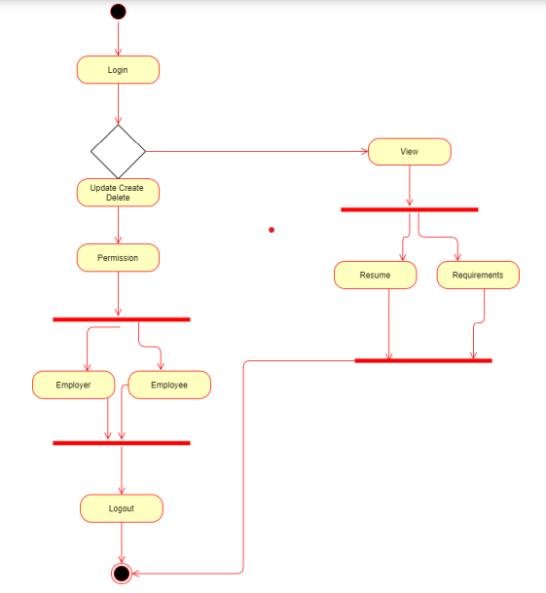

**EMPLOYER**

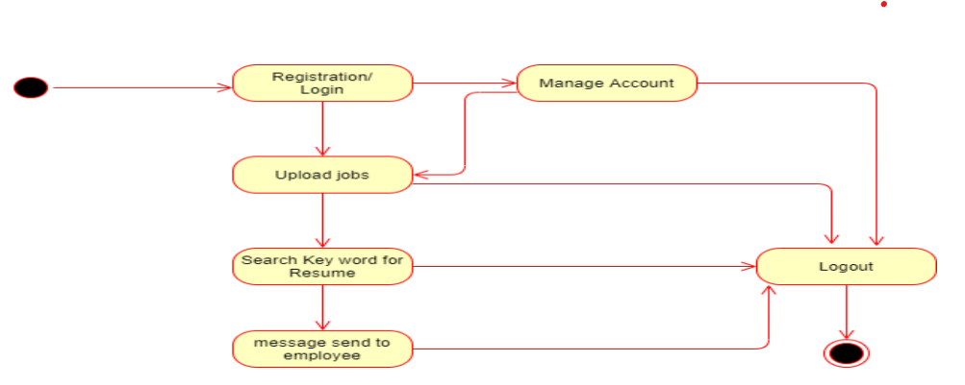

**USER**

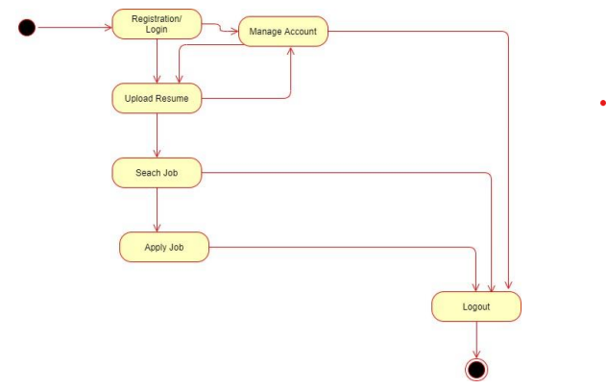

**6.2 E****ntity Relationship**

